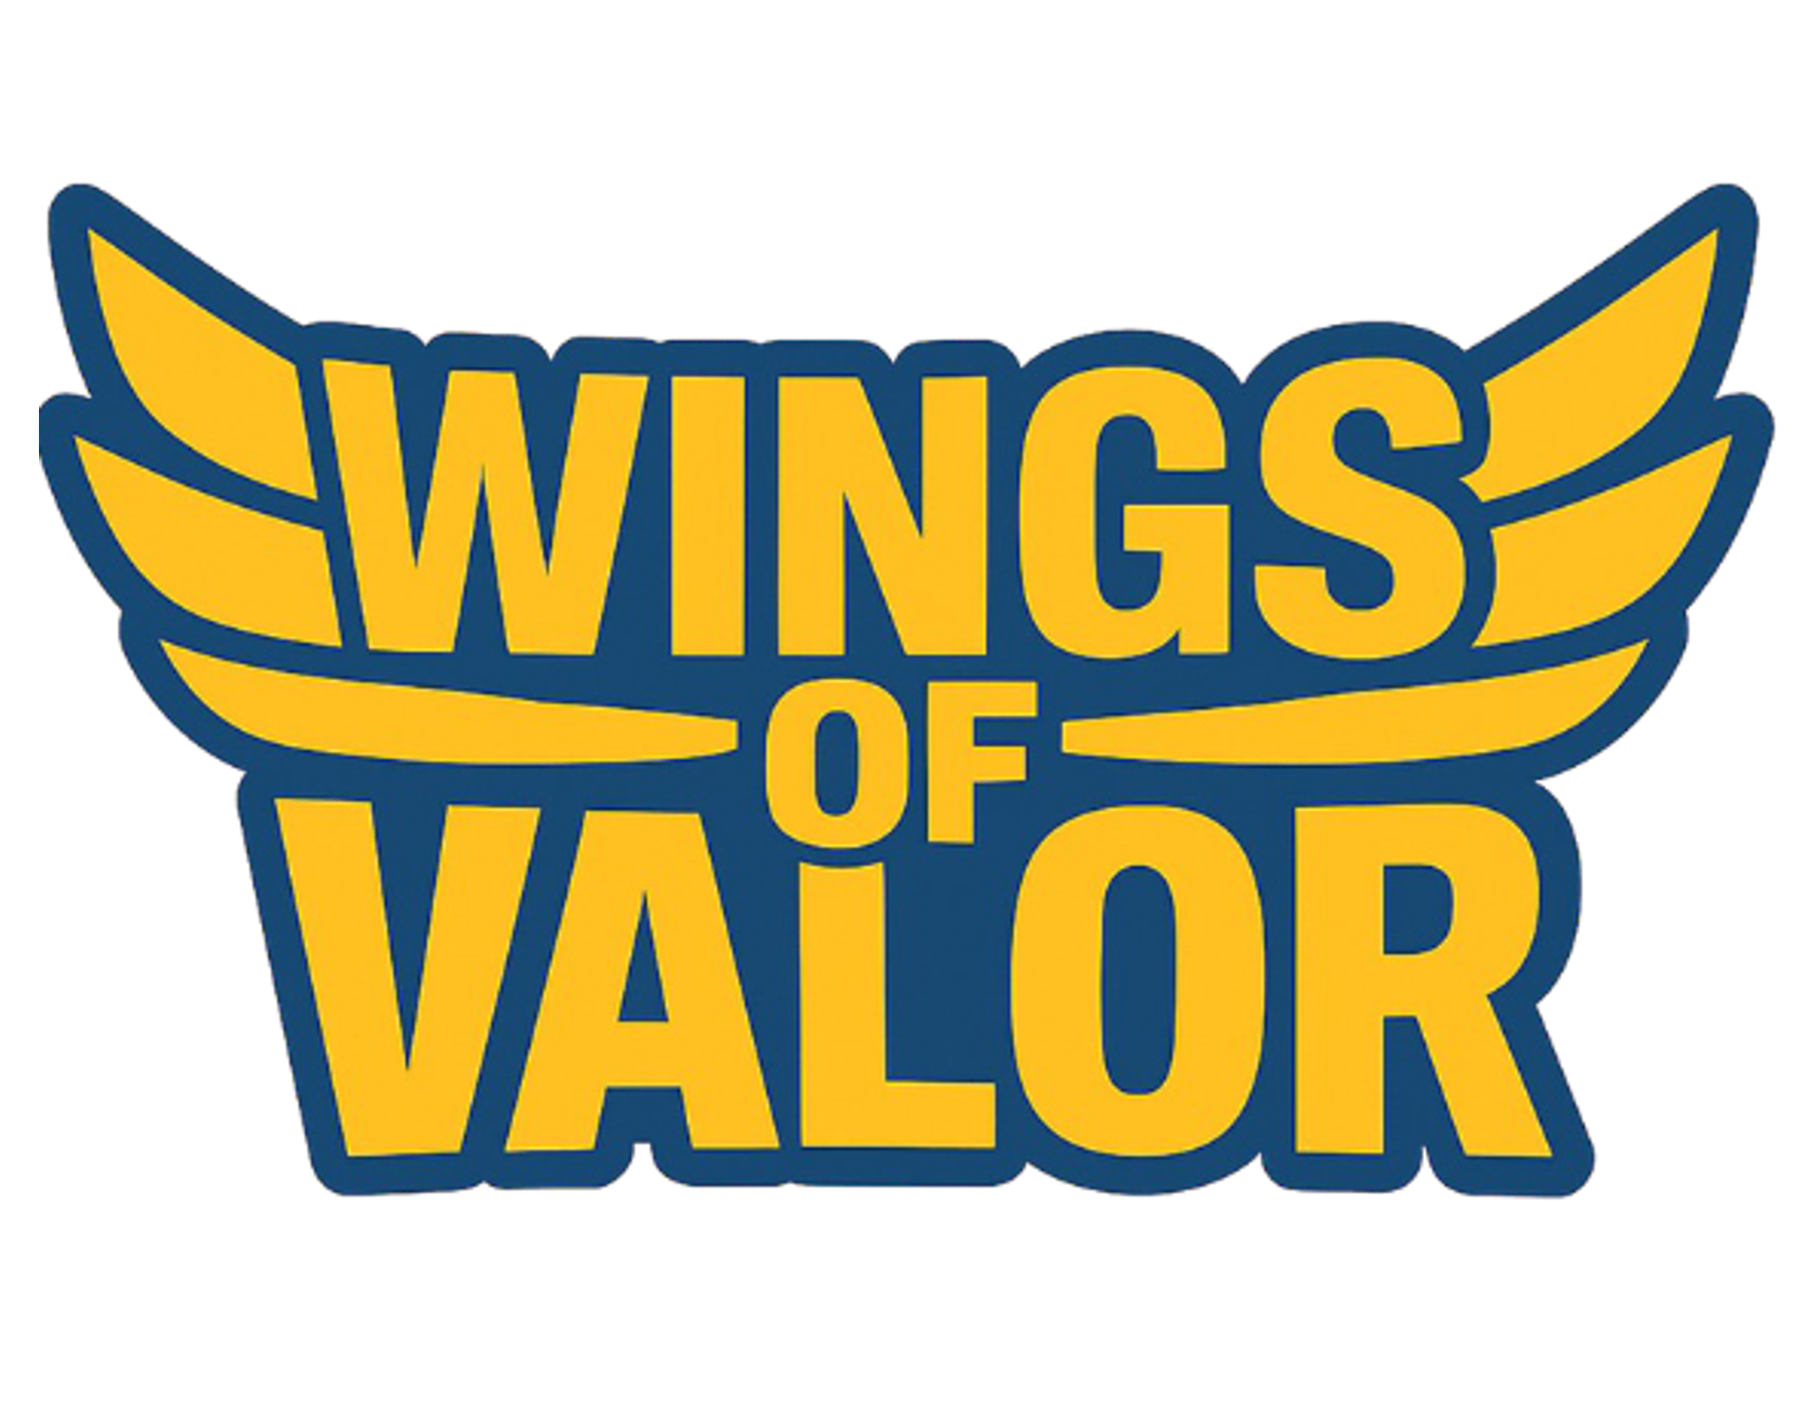


----------------

Go-To Market


Plan

----------------
Table of Contents
Overview 3
Key Differentiators 3
Audience and Market Position 3
Target Audience 3
Market Size and Opportunity 3
Competitive Position 4
Go-To-Market Strategy 4
Content & LiveOps Plan 5
KPIs & Success Criteria 5
Risks and Mitigation 6
Platform Visibility Risk: 6
Market Saturation and Competition: 6
Player Retention and Engagement: 7
Technical and Operational Risks: 7
Brand/IP Partnership Risks: 7
Monetization and Funding Risk: 7
Team Capacity and Burnout: 7
Player Safety, Moderation, and Compliance: 8
Community Sentiment & Reputation Risk: 8
Data Privacy and Security: 8
Dependence on External Tech or APIs: 8
Regulatory or Legal Risks: 8
References & Data Sources 9

Overview
Wings of Valor is a multiplayer PvP aerial combat game built for Unreal Editor for Fortnite (UEFN), featuring stylized, chibi WWII planes and fast five-to-ten-minute dogfights. Designed for Fortnite’s core audience, the game emphasizes instant action, skill-based progression without grind or pay-to-win, and a bright, accessible art style. Monetization and live service engagement are handled entirely through Epic’s Creator Program, with regular content updates planned and a sustained social media campaign to drive retention and growth in the UEFN ecosystem.

Key Differentiators
Wings of Valor combines the high-skill aerial combat of War Thunder with the instant fun and chaotic power-ups of Mario Kart; all built natively for Fortnite’s UEFN ecosystem. This is the first flying game on UEFN to offer true pick-up-and-play accessibility, fast-paced arcade combat, highly vertical interactive environments, and power-up abilities that keep matched balanced and unpredictable.

Unlike existing PvP islands or traditional flight games, Wings of Valor is session-based and immediately rewarding—there’s no grind, no pay-to-win, and no steep learning curve. The unique chibi-inspired plane designs are not only visually striking and made for social sharing, but also ideally suited for merchandising opportunities such as collectible toys, apparel, and digital stickers.

No other flying game on UEFN combines this level of accessibility, replay value, and cross-format commercial potential.

Audience and Market Position

Target Audience
Wings of Valor is designed for Fortnite’s Creative and PvP player base, with a focus on users aged 12–30 who prefer fast-paced, short-session multiplayer gameplay.

The game also appeals to fans of accessible, session-based dogfighting games, including players who enjoy titles like War Thunder and Ace Combat but prefer less complexity and lower barriers to entry.

Market Size and Opportunity
Fortnite currently averages over 30 million daily active users and sees 44.7 million unique players in a single day, with peak concurrent users exceeding 14 million during major events (Beebom, April 2025). UEFN and Creative content account for more than 5.2 billion play hours in 2024, with over 60,000 creator-made islands visited daily. Epic distributed $324 million to UEFN creators last year (Epic Games, 2024; GamesBeat, 2024), and PvP and vehicle-based maps routinely attract tens of thousands of concurrent players via the Discovery tab. Outside Fortnite, War Thunder has over 70 million registered users with 70,000–100,000 concurrent players, while Ace Combat has sold approximately 18 million copies as of 2021, with launch concurrency in the tens of thousands.

Competitive Position
Wings of Valor directly competes with popular UEFN islands centred on PvP and vehicle combat, including titles like Rocket Racing and Only Up, both of which consistently appear in Fortnite’s Discovery tab and community highlights. Outside the UEFN ecosystem, key competitors include standalone dogfighting franchises such as War Thunder and Ace Combat, which require higher commitment and longer session times. By offering accessible, skill-based dogfights in short five-to-ten-minute matches, fully integrated with Fortnite’s controls and visuals, Wings of Valor is positioned to capture a substantial segment of Fortnite’s active, session-driven audience.
The game’s emphasis on balanced gameplay, spectator-friendly design, and repeatable competitive sessions also supports strong esports potential. We are exploring strategic partnerships with tournament organizers such as EGL (European Gaming League) to run community tournaments and influencer-led competitions, driving player engagement and helping establish Wings of Valor as a competitive multiplayer title within the Fortnite ecosystem.

Go-To-Market Strategy
Wings of Valor will follow a phased release plan with clear milestones. Internal alpha is targeted for late December 2025, following completion of core gameplay and initial maps. Closed beta, involving external testing and targeted creator engagement, is planned for late June 2026. Public launch is scheduled for July 2026, but the date may be adjusted to follow a major Fortnite content cycle or event, allowing us to capitalize on heightened player attention while avoiding direct competition in the Discovery tab.

The primary marketing campaign, including the official game trailer, will be concentrated in the days immediately preceding launch, with the trailer set to debut on launch day or the day before. This approach, modelled after Epic’s LEGO Fortnite campaign, is intended to maximize impact with Fortnite’s player base, who respond strongly to high-visibility, last-minute reveals.

Marketing efforts will ideally be partner supported, and leverage coordinated influencer campaigns, social content, and creator seeding across TikTok, YouTube Shorts, and X (Twitter). Ongoing announcements and updates will be managed through Reddit’s FortniteCreative and FortniteBR subreddits. We will also initiate early outreach to tournament partners, such as EGL, to support launch events and early competitive engagement.

Post-launch, scheduled content updates in August–September 2026 and October–November 2026 will add new planes, maps, or gameplay features. The game’s scalable design enables flexible launch scope, ensuring a high-quality release under varying resource or feature conditions. All milestones and campaign activities are reviewed monthly and adjusted based on Epic’s UEFN platform roadmap and internal progress.

Content & LiveOps Plan
At launch, Wings of Valor will include three maps—Desert Ruins, Skyward Acropolis, and Frostbound Fjords, three distinct plane classes, a roster of chibi-styled WWII aircraft, and unlockable skins and stickers. Players will have access to a polished PvP dogfighting mode with five-to-ten-minute sessions, a powerup system, and streamlined onboarding.

Post-launch, the game will operate on a regular update cycle. The first major content update is scheduled for August–September 2026, and the second for October–November 2026, each introducing new planes, maps, and gameplay features. Balance updates, bug fixes, and quality-of-life improvements will be delivered as required, based on player analytics and feedback.

A full expansion, Skies of Desolation, is planned after the initial content updates and will introduce jet aircraft and new levels. Further ahead, we aim to deliver a space-themed content drop/expansion, targeting integration of external brands such as Star Wars and Dune, subject to commercial agreement and platform approval, these are aspirations targets.

Recurring community events and tournaments will be held, including the potential for Red Bull–style “air-race” modes and sponsored competitions in partnership with EGL (European Gaming League). All content and live operations are structured for scalability, with scope and schedule reviewed monthly and adjusted to player engagement and platform developments.

KPIs & Success Criteria
Wings of Valor’s post-launch performance will be tracked using analytics from Epic’s UEFN Content Creator Panel. Core KPIs will include daily and monthly active users (DAU/MAU), peak concurrent users, average session length, and retention rates—specifically Day 1, Day 7, and Day 30—to assess ongoing engagement and player value. Additional metrics will include participation in content updates, event and tournament engagement, and user-generated content activity such as replays and unlocks.

With a focus on building a close working relationship with Epic and securing sustained platform promotion, our top-tier targets for the first year are to achieve and sustain a daily active user base of 35,000 players, a monthly active user base of 70,000–200,000, and a total of 520,000 monthly play hours. Retention targets are set at 40–50% for Day 1, 15–30% for Day 7, and 10–20% for Day 30. We aim for at least 35% of monthly active users to participate in new content releases or live events within one week of each update. Session length, event participation, and engagement with new content will be closely tracked to inform LiveOps strategy and roadmap adjustments.

These engagement and retention targets are intentionally ambitious and benchmarked against the highest-performing UEFN islands to date. Achieving them will require consistent Discovery tab placement, ongoing Epic platform support, and a successful marketing campaign. We recognise that Epic’s algorithms and player trends are subject to change, and will review all KPIs quarterly, adapting goals as necessary in response to real-world data and evolving platform dynamics.

Success will be defined not only by meeting these engagement thresholds but by establishing Wings of Valor as a recognised, competitive brand within the Fortnite ecosystem, maintaining positive player sentiment, and sustaining long-term community growth—even as market and platform conditions evolve.

Risks and Mitigation

Platform Visibility Risk:
Wings of Valor’s success is highly dependent on ongoing visibility in the Fortnite Discovery tab and Epic’s platform promotion. Without sustained featuring, player acquisition and engagement may fall below targets.
Mitigation:
Engage early with Epic, present a polished vertical slice, and maintain close communication to maximize the opportunity for platform support. Content and LiveOps plans are structured to deliver consistent updates and community events, increasing the likelihood of ongoing promotion.

Market Saturation and Competition:
The UEFN ecosystem is crowded, with new islands launching weekly and direct competition from established titles.
Mitigation:
Launch timing will be strategically planned to avoid major Fortnite events and updates. The game will differentiate through high production quality, unique gameplay, scalable content, and partnerships (e.g., EGL), ensuring sustained player interest and event-driven spikes.

Player Retention and Engagement:
Sustaining high retention and participation rates is challenging, particularly as player novelty fades or new competitors emerge.
Mitigation:
Data-driven LiveOps and regular content updates—including tournaments and sponsored events—will keep the game fresh and engaging. Early player feedback will be closely monitored, and rapid iteration will be prioritized to address pain points and feature requests.

Technical and Operational Risks:
UEFN platform updates, Epic policy changes, or unforeseen technical issues may disrupt service or require significant rework.
Mitigation:
The game is architected for scalability and rapid content adjustment. Regular communication with Epic and flexible development processes will allow rapid response to platform changes or requirements.

Brand/IP Partnership Risks:
Plans for brand integrations and third-party partnerships (e.g., Star Wars, Dune, Red Bull) may be delayed, denied, or altered due to external factors beyond our control.
Mitigation:
All brand and IP partnerships will be pursued as opportunistic enhancements, not core dependencies. The live roadmap is designed to deliver value to players regardless of external deal timing, with contingency content always in development.

Monetization and Funding Risk:
Epic’s Creator Program terms, payout algorithms, or player regional mix may change, impacting projected revenue.
Mitigation:
The business model remains focused on maximizing engagement time and community igfpartnerships, events, and other channels will be explored to reduce dependency on a single monetization stream.

Team Capacity and Burnout:
A small team or inexperience with live service models can increase the risk of burnout, missed content updates, or slower iteration, especially as LiveOps demands grow.
Mitigation: Regular milestone reviews, flexible scope, and strategic outsourcing will be used to balance workload and avoid overextension.

Player Safety, Moderation, and Compliance:
Toxicity, griefing, or moderation failures can damage reputation and negatively impact the player experience, especially in PvP games targeting younger audiences. While Epic does not provide creators with persistent ban or block tools at the island level, we will implement in-game systems to detect and isolate disruptive players. Those who engage in harmful or unfriendly behaviour will be placed in a session-based “ban room,” restricting their access to gameplay either indefinitely or for a specified period, as an in-island deterrent. All such incidents and player reports will be escalated to Epic for formal review and enforcement under their global moderation policies. Clear reporting mechanisms will be provided, and player safety will remain a top operational priority.

Community Sentiment & Reputation Risk:
A single negative incident, unpopular update, or miscommunication can trigger community backlash and loss of goodwill.
Mitigation:
Transparent communication, active listening on all channels, and rapid course correction will be core to the community management approach.

Data Privacy and Security:
Any data leak, privacy breach, or misuse of player information—even if accidental—can have severe legal and reputational consequences.
Mitigation:
Strictly follow Epic’s data policies and minimize any direct data collection. Rely on platform-native tools wherever possible.

Dependence on External Tech or APIs:
If the game relies on third-party plugins, APIs, or non-Epic tech, updates or deprecations could break critical features.
Mitigation:
Maintain contingency plans for key dependencies and regularly review all integrations for ongoing compatibility.

Regulatory or Legal Risks:
Changes in digital content laws, age restrictions, or global compliance rules could impact accessibility or revenue streams, especially for a younger audience.
Mitigation:
Ongoing legal review and alignment with Epic’s own compliance practices.

References & Data Sources

Fortnite Player Counts and Engagement
Beebom: “Fortnite Player Count (2024)”
https://beebom.com/fortnite-player-count/

Epic Games Official Stats and Press Releases
https://www.epicgames.com/news

Epic Games UEFN Creator Program and Payouts
Epic Games: “UEFN Engagement Payouts and 2024 Year in Review”
https://create.fortnite.com/news/fortnite-ecosystem-2024-year-in-review-celebrating-creators-and-looking-ahead

GamesBeat/VentureBeat: “Epic paid $324 million to Fortnite Creative and UEFN creators in 2023”
https://venturebeat.com/games/epic-paid-324m-to-fortnite-creative-and-uefn-creators-in-2023/

War Thunder and Ace Combat User Numbers
Gaijin Entertainment (War Thunder):
https://warthunder.com/en/news/8231-news-70-million-players-and-a-new-game-engine-en

SteamDB (War Thunder concurrents):
https://steamdb.info/app/236390/graphs/

Bandai Namco (Ace Combat sales):
https://www.bandainamcoent.com/news/ace-combat-franchise-sales-milestone

IGN: “Ace Combat 7 Ships 4 Million Units”
https://www.ign.com/articles/ace-combat-7-ships-4-million-units

Fortnite UEFN Island Competition and Examples
Fortnite Creator Portal/Discovery Tab (examples: Rocket Racing, Only Up):
https://www.fortnite.com/creative

Reddit: FortniteCreative and industry roundups
https://www.reddit.com/r/FortniteCreative/

UEFN Island Moderation and Player Reporting
Epic Games: “Player Reporting and Moderation in Fortnite Creative”
https://www.fortnite.com/news/fortnite-creative-player-reporting?lang=en-US

Epic Games: Official Documentation for Moderation and Island Management
https://dev.epicgames.com/documentation/en-us/fortnite/island-settings-in-unreal-editor-for-fortnite

UEFN Creator Economy and Payout Discussion
X/Twitter: Creator and industry disclosures of payout rates (various, e.g. ImmatureGamerX, Dummblond, etc.)

Various Discord/industry roundups (non-public but referenced for earnings ranges)
Legal, Regulatory, and Compliance
Epic Games Developer Policies
https://www.epicgames.com/site/en-US/fan-art-policy

General Data Protection and Player Safety Resources (EU/US digital content law)
Internal Studio/Design Docs

Raging Bear Interactive: Wings of Valor Game Design Document (GDD) and Pitch Deck

